Skin care chatbot implementation guideline
Technologies used:
- Rasa: NLP chatbot framework
- Python 3.10: Backend programming language
- Ollama: Local server for running Llama models
- Fine-tuned Llama model
- Fine-tuned BioBERT models
Development steps:
- Environment preparation:
- Install python 3.10
- Create virtual environment with python 3.10:
“C:\Users\User\AppData\Local\Programs\Python\Python310\python.exe python -m venv rasa_env”
- Install Rasa inside the virtual environment
Activate environment:
“ .\rasa_env\Scripts\activate”
Rasa install:
“pip install rasa”
“rasa -version”
- Install required libraries for BioBERT model:
“pip install transformers”
“pip install torch”
“pip install requests”
- Initialize Rasa chatbot:
- Create Rasa project
“rasa init --no-prompt”
This will create a folder structure like:
/your project
/data (nlu.yml, rules.yml, stories.yml
/actions.py
Domain.yml
Config.yml
- Llama server preparation:
Download and install Ollama locally
- Running fine-tuned Llama model:
- Copy all the necessary files in new directory
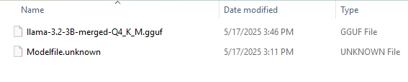
- In the command prompt run the model creation command:
“ollama create derm-assistant -f Modelfile”
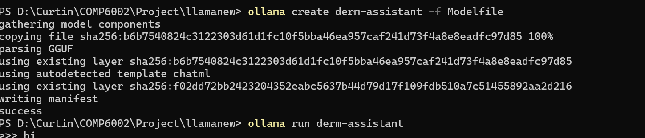
- Run model starting command
“ollama run derm-assistant”
- Prepare fine-tuned BioBERT models:
- Copy fine-tuned models into your Rasa project folder:
Fine-tuned Intent Classifier | ./fine-tuned-biobert-psoriasis-intent-v2/
Fine-tuned NER Model | ./fine-tuned-biobert-ner-v2/
- Prepare Rasa config files
- Copy all developed Rasa files in the appropriate path of Rasa project folder:
- actions.py
- config.yml
- domain.yml
- nlu.yml
- rules.yml
- stories.yml
- Train the rasa with newly copied config files:
“.\rasa_env\Scripts\activate”
“rasa train”
- Start the Rasa action server background
“rasa run actions” (for only starting rasa action server without integrating FE) or
“Bashrasa run – enable-api –cors “*” “ (for starting action server with FE)
- Start the Rasa shell (for only testing chatbot with rasa command prompt)
“rasa shell”

